Ideation Phase

Define the Problem Statements

|  |  |
| --- | --- |
| Date: | 18 June 2025 |
| Team ID: | LTVIP2025TMID47029 |
| Project Name: | Enchanted Wings: Marvels of  Butterfly Species |
| Maximum Marks: | 2 Marks |

# Problem Statement (PS-1):

**I am** a biodiversity researcher

**I’m trying to** identify butterfly species during field research

**But** I often lack fast, accurate references in the field

**Because** printed identification guides are slow to use and manual classification is error-prone

**Which makes me feel** frustrated, delayed, and worried about data accuracy

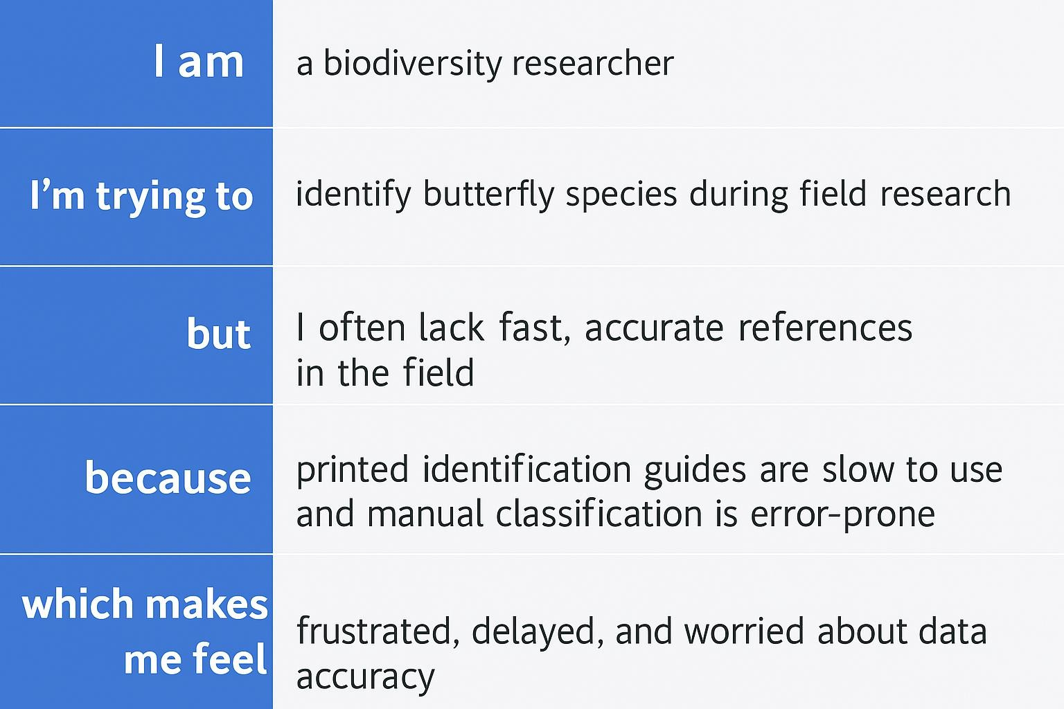

# Why This Matters

Understanding these challenges allows the team to build an AI-powered solution

that empowers users with real-time, accurate butterfly identification.

This helps boost engagement, reduce errors, and supports conservation and research.